|  |  |  |  |
| --- | --- | --- | --- |
| **EMPID** | **EMPNAME** | **DOJ** | **ROWID** |
| **1** | **Akshay** | **22-apr-2020** | **A1** |
| **2** | **amey** | **23-feb-2020** | **A2** |
| **1** | **Akshay** | **22-apr-2020** | **A3** |
| **1** | **Akshay** | **22-apr-2020** | **A4** |

**Table name is emp**

**First we know the row id of dulicate records so**

**Run this command**

**SELECT ROWID,EMPID,EMPNAME FROM emp WHERE EMPID=1**

**Empid=1 why because it is dulicate records emp id is 1**

|  |  |  |
| --- | --- | --- |
| **EMPID** | **EMPNAME** | **ROWID** |
| **1** | **Akshay** | **A1** |
| **2** | **amey** | **A2** |
| **1** | **Akshay** | **A3** |
| **1** | **Akshay** | **A4** |

**select min and first rowid the put on this query**

**DELETE FROM EMP WHERE EMPID=1 AND ROWID NOT IN(SELECT MIN(‘A1’) FROM EMP GROUP BY EMPID,EMPNAME,DOJ);**

|  |  |  |  |
| --- | --- | --- | --- |
| **EMPID** | **EMPNAME** | **DOJ** | **ROWID** |
| **1** | **Akshay** | **22-apr-2020** | **A1** |
| **2** | **amey** | **23-feb-2020** | **A2** |

**Query:-**

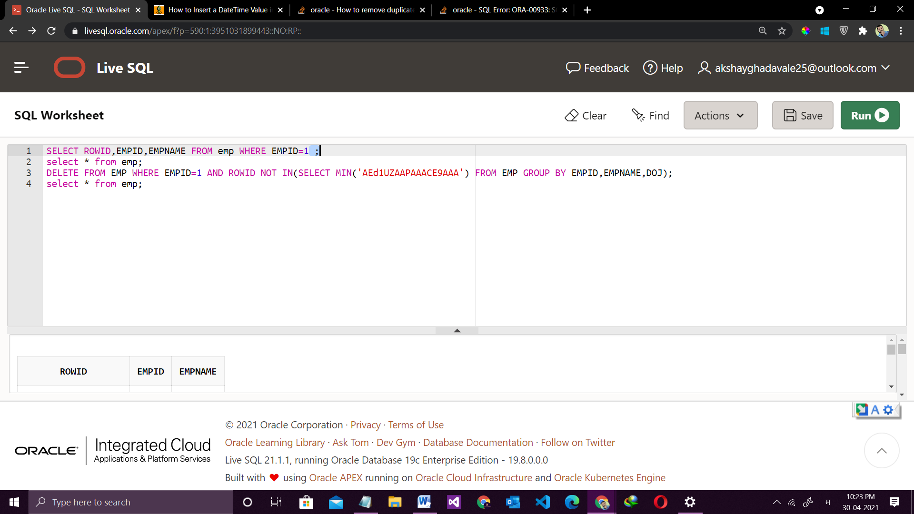

**practical:-**

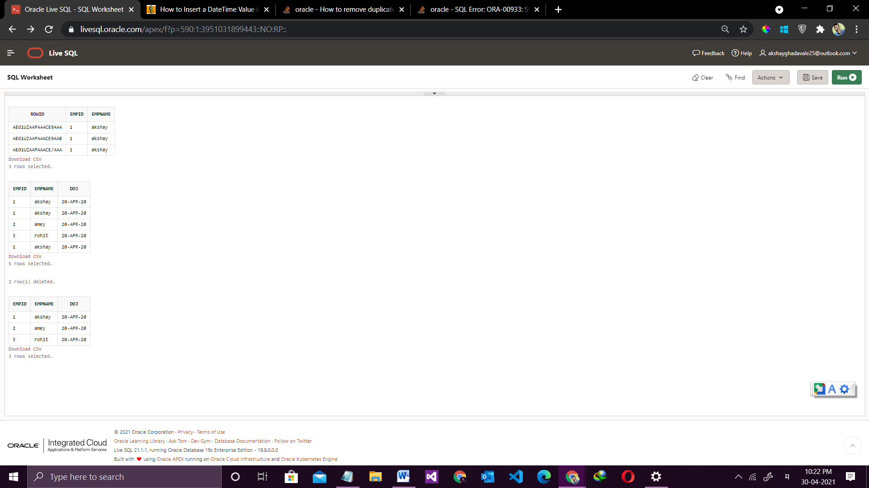

Above query is is delete at the time one of dulicate record

**But this query detele all the dulicates of perent in table**

**IMPORTANT!**

**DELETE FROM emp A WHERE A.rowid > any ( SELECT B.rowid FROM emp B WHERE A.empid = B.empid AND A.empname = B.empname );**